|  |  |
| --- | --- |
| **Practicum Case** |  |
| COMP6140  Data Mining |
| **Computer Science** | **O191-COMP6140-NP01-03** |
| ***Valid on*** *Even Semester Year 2019/2020* | **Revision 00** |

## Soal

*Case*

**NPEX Cryptocurrency Market**

**NPEX** is a grand cryptocurrency exchange market which mainly focuses exchange of **IDR** (Rupiah) with various major cryptocurrencies such as **BTC** (Bitcoin), **ETH** (Ethereum), and **XRP** (Ripple). To maintain its exponential growth, NPEX is currently adapting the use of **R** to analyze its market data. As a data scientist of NPEX company, you are asked to analyze the market data according to the following tasks.

1. **Read** the **.csv** file and **divide** the data based on their cryptocurrency.
2. Since the data is shuffled, **order** the data based on **date** and **time** in ascending order.
3. **Calculate** **Open** and **Close** price of **ETH** (Ethereum) on 16 August (**Open** price means the first price of the market when it opened on the day, and **Close** price means the last price in the end of the day).



Figure 1.1. Ethereum Open Price



Figure 1.2. Ethereum Close Price

1. **Calculate High** and **Low** price of **BTC** (Bitcoin) on 15 August (**High** price means the highest price of the market on the day, while **Low** price means the lowest price of the market).



Figure 2.1. Bitcoin Low Price



Figure 2.2. Bitcoin High Price

1. **Summarize** the price of **XRP** (Ripple) on 18 August and calculate its **Mean**, **Median**, and **Standard Deviation**.

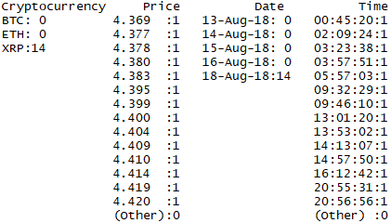

Figure 3.1. Ripple Summary



Figure 3.2. Ripple Average Price



Figure 3.3. Ripple Median Price



Figure 3.4. Standard Deviation for Ripple Price